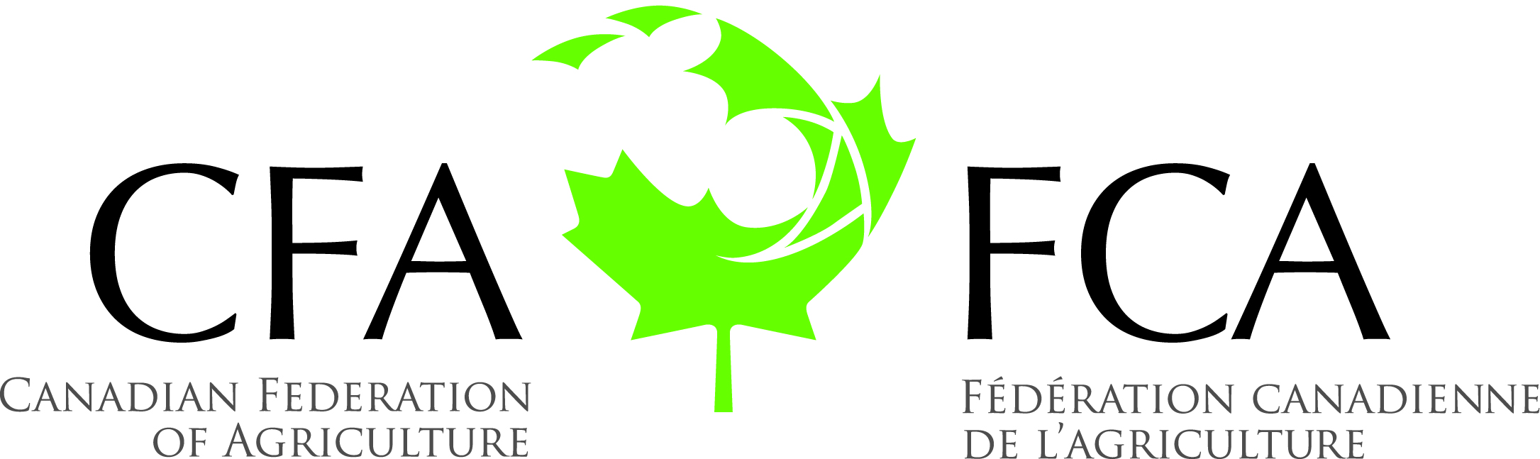
Canadian Federation of Agriculture
Summer Meeting 2019
Delta Hotels by Marriott Québec
690 Boul. René-Lévesque Est, Québec, Québec
July 15-17, 2019
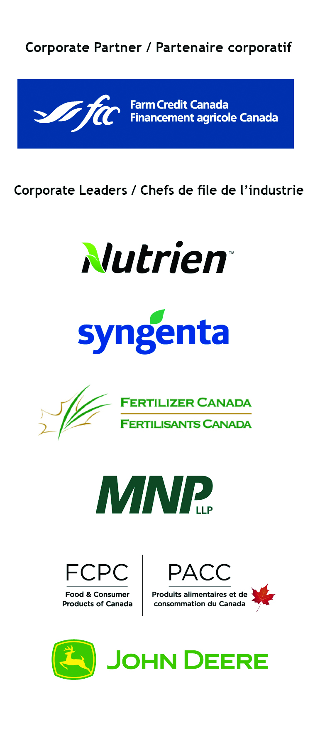
Monday, July 15 (Duquesne/Jonquière room)
SPECIAL ISSUE COMMITTEE MEETINGS
(Note: All meeting participants may attend committee meetings as observers.)
CFA Office: Buade room
WIFI Code:
8:30 am | Registration
9:00 – 10:30 am | Governance Committee – Closed Session (Members only) – Room Duquesne/Jonquière
9:00 – 10:30 am | Lab-Based Meats Committee – Closed Session (Members Only) – Room Lauzon
10:30 – 12:00 pm | TFWP Housing Committee – Closed Session (Members Only) – Room Duquesne/Jonquière
10:30 – 12:00 pm | Food Loss Steering Committee – Closed Session (Members Only) – Room Lauzon
12:00 – 1:00 pm | LUNCH – Room Crémazie/Garneau
1:00 – 1:15 pm | Opening Remarks – Closed Session (Members only) Mary Robinson, CFA President
1:15 – 2:00 pm | Administration – Closed Session (Members Only)  - Roll Call  - Adoption of Agenda  - Approval of the April 2019 Board Meeting Minutes  - Preliminary discussion on proposed 2020 Budget
Monday, July 15
2:00 – 2:30 pm | Communications & Sponsorship Update – Closed Session (Members Only)  Laurie Karson
2:30 – 3:15 pm | Mid-Term Strategic Plan Review – Closed Session (Members Only)  - Longer Term Policy Issues
3:15 – 3:45 pm | CFA Resolution Update  Errol Halkai & Policy Staff
3:45 – 4:00 pm | Update on Meetings with Federal Parties Agriculture Caucus  Mary Robinson
4:00 – 4:15 pm | Health Break
4:15 – 5:00 pm | Producing Prosperity Campaign Update  Peter Seemann

Tuesday, July 16
9:00 – 9:30 am | Regional Issues Update: UPA  Marcel Groleau, UPA
9:45 – 10:15 am | Overview of Federal Budget Priorities – Pre-Budget  Scott Ross
10:15 – 10:30 am | Health Break
10:30 – 11:00 am | BRM Update Scott Ross
11:00 – 11:30 am | Inter-American Institute for Cooperation on Agriculture Dr. François Dagenais
11:30 – 12:30 pm | LUNCH – Room Crémazie/Garneau
12:30 – 12:45 pm | Public Trust Steering Committee Update  Ron Bonnett
12:45 – 1:00 pm | Brigid Rivoire Memorial Award & Mental Health Update  Scott Ross
1:00 – 1:15 pm | WFO General Assembly – Update  Keith Currie
1:15 – 1:30 pm | Update on the Amendment to the Fisheries Act  Frank Annau
1:30 – 2:30 pm | International Trade Update Fred Gorrell (TBC)
2:30 – 2:45 pm | In-Camera Session
2:45 – 3:00 pm | Health Break
3:00 – 3:30 pm | Welcoming Remarks  The Honourable André Lamontagne  MAPAQ
5:30 – 9:30 pm | Tribute Dinner for Ron Bonnett  Manoir Montmorency  -Buses will leave from the Delta Hotel at 5:30pm

Wednesday, July 17

8:30 – 9:30 am | Committee Reports  - Governance – Kurt Siemens – Closed Session (Members Only)  - Food Loss – Lynda Atkinson  - TFWP Housing – Mike Medeiros  - Lab-Based Meats – Bill Campbell
9:30 – 10:15 am | FPT Roundtable Strategy Session – Closed Session (Members Only)  Mary Robinson
10:15 – 10:30 am | Health Break
10:30 – 11:00 am | CropLife Canada  Pierre Petelle
11:00 – 11:30 am | Fertilizer Canada  Catherine King
11:30 – 12:00 pm | Update on VCRT’s  Glenda Taylor, AAFC
12:00 – 12:30 pm | National Food Policy Update  Tom Rosser
12:30 pm | Adjournment
12:30 – 1:30 pm | LUNCH – Room Crémazie/Garneau
5:00 pm – 6:00 pm | CFA/FPT Ministers’ Tripartite Roundtable – Room Duquesne/Jonquière
7:00 pm | FPT Minister’s Reception

Other Meeting: Wednesday, July 17
2:00 – 3:30 pm | Seed Sector Innovation Committee Meeting – Room Lauzon

MARK YOUR CALENDARS
CFA 2019/2020 MEETINGS:
October 28-30 Board of Directors Meeting, CFA Offices, 21 Florence Street
February 26-27, 2020 Annual General Meeting, Fairmont Chateau Laurier, Ottawa
February 28, 2020 Board of Directors Meeting, Fairmont Chateau Laurier, Ottawa

OTHER MEETINGS:
September 4-5 General Managers Meeting, Coast High Country Inn, Whitehorse, YT
September 18-20 NA/EU Farm Leaders Meeting, Copenhagen
December 2-4 Agriculture Excellence Conference, Fredericton, New Brunswick
December 3-5 Grow Canada Conference, Calgary

